|  |
| --- |
| HUTECH UNIVERSITY OF TECHNOLOGY  *****************  **WEB PRAMMING**  **Final Test Report**    **Group:**   1. **Do Hoang Cong Danh_2011064187** 2. **Tran Nguyen Bao Toan_2011061154**   **Ho Chi Minh City, 12/2022** |

Step 1:

Using Git to clone the project on GitHub with link:

<https://github.com/BToan22/CMP175_WebFinalProject.git>

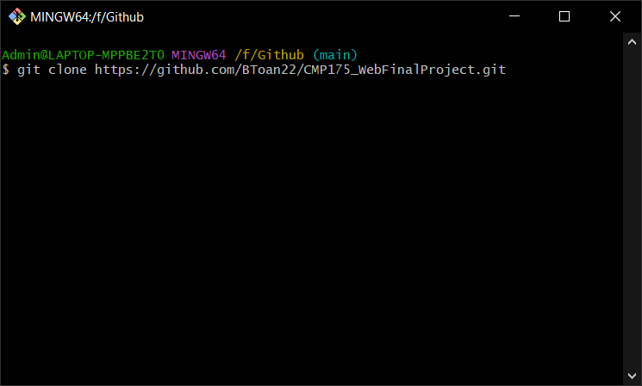

Step 2:

Using the WebFinalScript file and excute it on Microsoft SQLServer.

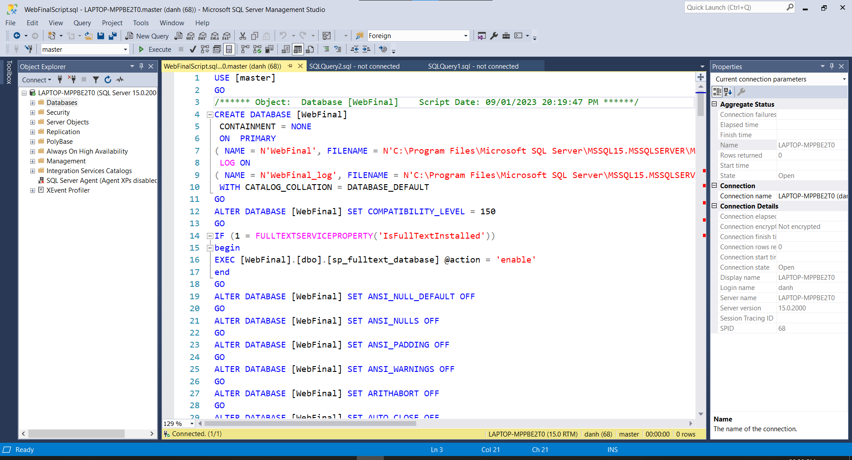

Step 3:

Delete table dbo.Provinces and right click on database WebFinal 🡪 Task 🡪 Import Data and import file Provinces.xls.

Step 4:

Open folder WebFinal and double click file WebFinal.sln to run project on Visual Studio.

Step 5:

Open LoginController in project.

In line 117 change the Server equal to your server name in Microsoft SQLServer.

Change user id and password equal the user login you have.

Step 6:

Excute the WebFinal project

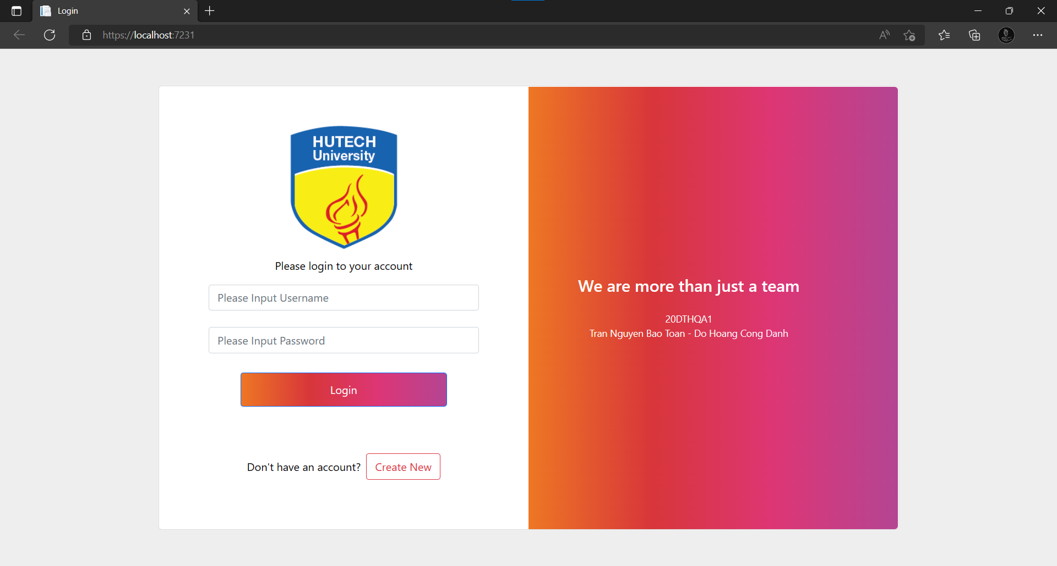

Step 7:

Click Create New to Register and click Register

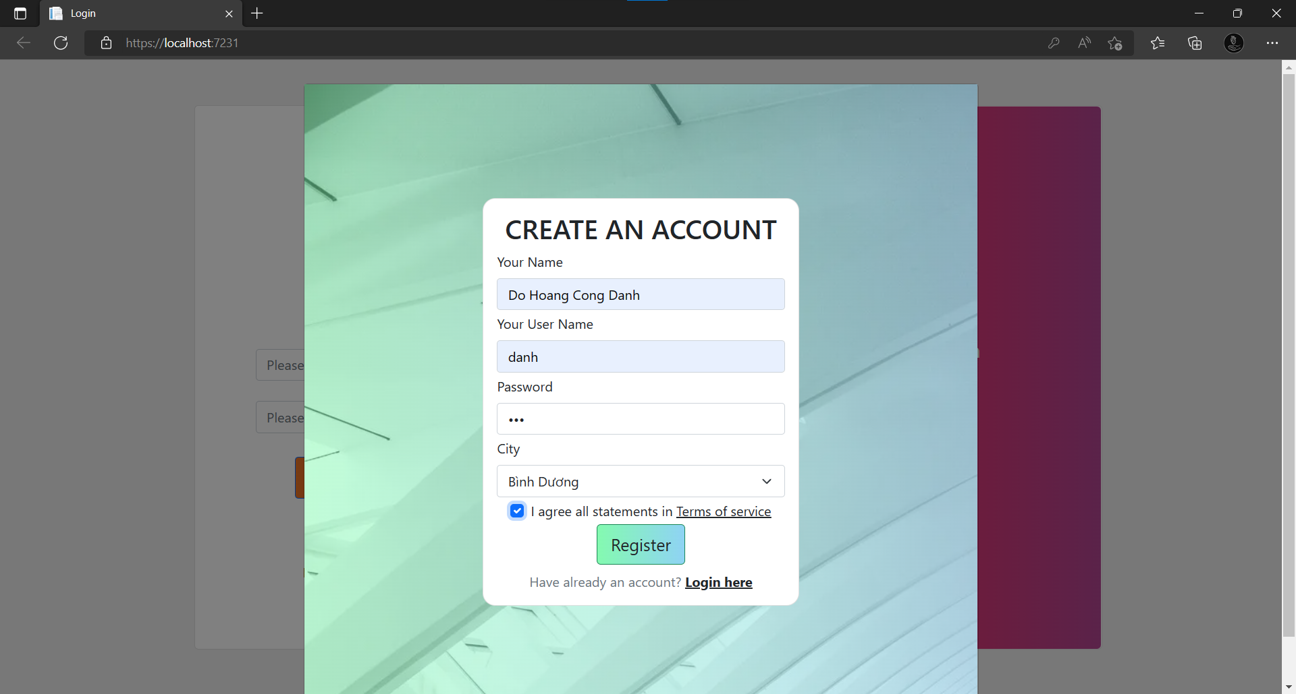

Step 8: Click Home Page to return the login form and fill your user name and password

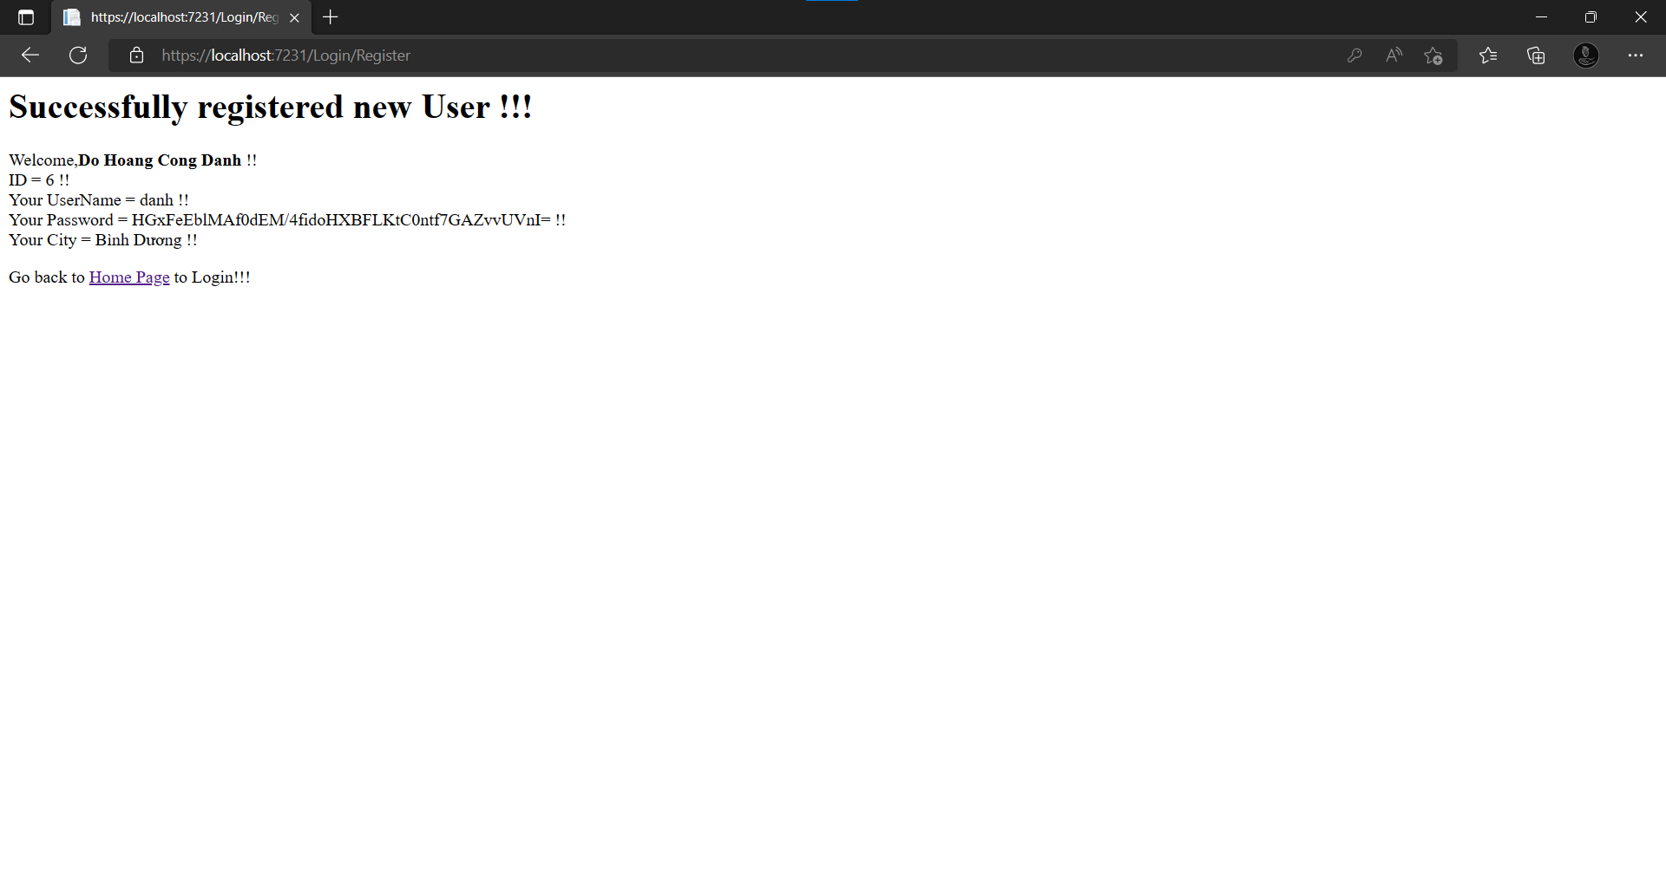

LIKE THIS and click login

